Event-Triggered Communication
# Source: AI Source: Provided by: [Data Path: Persons Table -> ID Column: 1, Name_En Column: Motasem Essam] -> From: [ChatGPT] on [1/21/2026]
Event-Triggered Communication is the second major type of Real-Time Communication, used in systems where messages are sent in response to events rather than at fixed time intervals.

Definition
# Source: AI Source: Provided by: [Data Path: Persons Table -> ID Column: 1, Name_En Column: Motasem Essam] -> From: [ChatGPT] on [1/21/2026]
Event-triggered communication is a method where:
- A task sends a message only when an event occurs, such as:
  - Sensor reading exceeds a threshold
  - Button press
  - Error condition
- Communication is asynchronous and not pre-scheduled.

Key Features
# Source: AI Source: Provided by: [Data Path: Persons Table -> ID Column: 1, Name_En Column: Motasem Essam] -> From: [ChatGPT] on [1/21/2026]
- Asynchronous
  - Messages are transmitted only when needed, not at fixed times.
- Dynamic
  - Works well for sporadic or unpredictable events.
- Lower Resource Usage
  - Network bandwidth and CPU are used only when events occur.
- Less Deterministic
  - Timing of message delivery can vary, unlike time-triggered communication.

Example
# Source: AI Source: Provided by: [Data Path: Persons Table -> ID Column: 1, Name_En Column: Motasem Essam] -> From: [ChatGPT] on [1/21/2026]
In a smart home system:
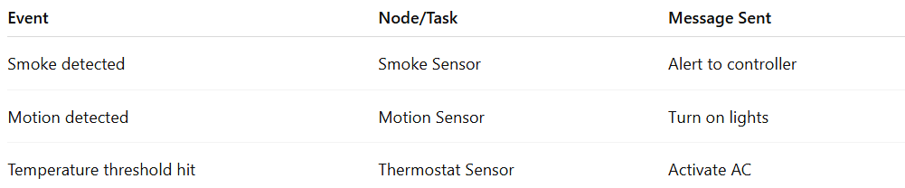
Event | Node/Task | Message Sent
Smoke detected | Smoke Sensor | Alert to controller
Motion detected | Motion Sensor | Turn on lights
Temperature threshold hit | Thermostat Sensor | Activate AC
- Messages are sent only when events occur.
- The system responds dynamically, without wasting bandwidth on unnecessary transmissions.

Advantages
# Source: AI Source: Provided by: [Data Path: Persons Table -> ID Column: 1, Name_En Column: Motasem Essam] -> From: [ChatGPT] on [1/21/2026]
- Efficient use of network and CPU resources
- Flexible – easily accommodates new tasks or events
- Suitable for soft real-time systems or systems with unpredictable events

Disadvantages
# Source: AI Source: Provided by: [Data Path: Persons Table -> ID Column: 1, Name_En Column: Motasem Essam] -> From: [ChatGPT] on [1/21/2026]
- Non-deterministic – response time can vary due to network delays or contention
- Harder to guarantee deadlines in hard real-time systems
- Can cause priority inversion if multiple events occur simultaneously

Applications
# Source: AI Source: Provided by: [Data Path: Persons Table -> ID Column: 1, Name_En Column: Motasem Essam] -> From: [ChatGPT] on [1/21/2026]
- Home automation systems
- Industrial monitoring (alert on sensor thresholds)
- Embedded systems with sporadic events
- Event-driven robotics and IoT devices

Time-Triggered vs Event-Triggered Communication (Quick Comparison)
# Source: AI Source: Provided by: [Data Path: Persons Table -> ID Column: 1, Name_En Column: Motasem Essam] -> From: [ChatGPT] on [1/21/2026]
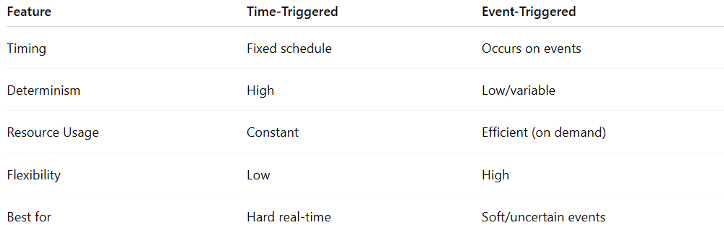
Feature | Time-Triggered | Event-Triggered
Timing | Fixed schedule | Occurs on events
Determinism | High | Low/variable
Resource Usage | Constant | Efficient (on demand)
Flexibility | Low | High
Best for | Hard real-time | Soft/uncertain events

